<!DOCTYPE html>

<html lang="en">

<head>

    <meta charset="UTF-8">`

    <meta name="viewport" content="width=device-width, initial-scale=1.0">

    <title>Priyanshu's form </title>

</head>

<body style="background-color: #f8f7f5;" alink="red" vlink="orange" link="green">

       <a href="assign2.html">HOME</a>

      <p style="color: brown; margin-left:50%" ><font size="5"> <b><u>Student Registration From</u></b></font>  </p>

    <form style="text-align: left;">

        <label >First Name:</label>

        <input style="margin-left:5%;" type="text" name=" FIRST NAME" placeholder="Enter your first name" required size="40" maxlength="40">

        <br>

        <label >Last Name:</label>

       <input style="margin-left:5.1%;"  type="text" name=" LAST NAME" placeholder="Enter your last name" required size="40">

        <br>

        <label > Email :</label>

       <input style="margin-left:9.4%;"  type="email" name="email" placeholder="Enter your email" required size="40">

       <br>

        <label >Mobile:</label>

         <input style="margin-left:8.8%;"  type="tel" name="mobile" placeholder="it should be of 10 digits" pattern="[0-9]{10}" required autofocus size="40" maxlength="10" minlength="10" >

        <br>

        <label >Gender :</label>

        <input style="margin-left:8.5%;"  type="radio" name="Gender" >male

        <input type="radio" name="Gender"> female

        <br>

        <label>Date of Birth :</label>

       <input style="margin-left:4%;"  type="date" name="DOB" required max="2024-07-13" min="2012-12-12">

        <br>

       <label>address:</label>

       <textarea style="margin-left:6.5%;" maxlength="300" rows="10" cols="50" ></textarea>

        <br>

        <label>city :</label>

        <input style="margin-left:10.5%;"  type="text" name="city" placeholder="Enter your city. " required size="40">

        <br>

        <label>Area Pin: </label>

       <input style="margin-left:6.1%;"  type="text" name="pin" placeholder="Enter your pin" size="40" maxlength="6" minlength="6">

        <br>

        <label>State</label>

       <input style="margin-left:10.6%;" type="text" name="state" placeholder="Enter your state">

        <br>

        <label>Qualification:</label>

        <select style="margin-left:2%;" name=" qualification">

           <option> BTECH CSE</option>

           <option> BTECH CSE CORE</option>

           <option> BTECH CSE AIML</option>

           <option> BTECH CSE CyberSecurity</option>

        </select>

        <br>

        <label>Specialization:</label>

        <input style="margin-left:3%;" type="checkbox" name="computer science">Computer Science

        <br>

        <input style="margin-left:18.3%;" type="checkbox" name="Information Technology">Information Technology

        <br>

       <input style="margin-left:18.3%;" type="checkbox" name="Computer Architecture">Computer Architecture

        <br>

        <input style="margin-left:18.3%;" type="checkbox" name="Tele Computer">Tele Computer

        <br>

        <label>Password:</label>

        <input style="margin-left:6%;"type="password" name="passward" required maxlength="8" minlength="8">

        <br>

        <br>

        <input style="margin-left:15%;"  type="submit" name="submit" >

       </form>

</body>

</html>

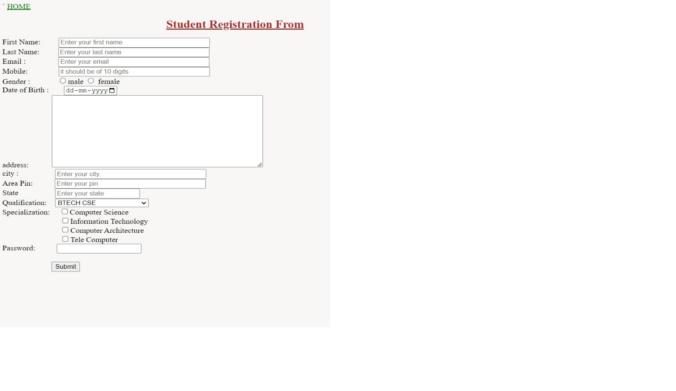

Output:-